🐧 Linux – Basic Introduction (Notes)

1️⃣ What is Linux?
- Linux is a free and open-source operating system.
- An operating system (OS) is software that:
-Manages hardware (CPU, memory, disk)
-Allows users to run applications
-Acts as a bridge between user and hardware
Examples of OS:
- Windows
- macOS
- Linux
👉 Linux is widely used in:
- Servers
- Cloud (AWS, Azure, GCP)
- DevOps
- Embedded systems
- Android (based on Linux kernel)

2️⃣ Why Linux is Important?
Linux is important because:
- It is free and open source
- Very stable and secure
- Can handle multiple users
- Highly customizable
- Best OS for servers and cloud
- Used heavily in DevOps & deployment
📌 Most production servers run on Linux, not Windows.

3️⃣ History of Linux
In 1991, a student named Linus Torvalds created Linux
He created the Linux Kernel
Inspired by UNIX
Released it as open source
👉 Developers worldwide contributed to it
👉 Linux became powerful and widely adopted
📌 Linux itself is not UNIX, but UNIX-like

4️⃣ What is Kernel?
Kernel is the core (heart) of Linux OS
It:
- Communicates with hardware
- Manages CPU, memory, disk
- Controls processes and system calls
📌 User does NOT directly interact with kernel.
5️⃣ Linux Architecture
User
↓
Shell (Bash)
↓
Kernel
↓
Hardware

Explanation:
- User → gives commands
- Shell → interprets commands
- Kernel → executes commands
- Hardware → actual work happens

6️⃣ What is Shell?
Shell is an interface between user and kernel
It:
- Accepts commands from user
- Sends them to kernel for execution
- Shows output to user
- Popular shells:
- Bourne Shell (sh)
Bash (Bourne Again Shell) ⭐
- Zsh
- Ksh

📌 Bash is the most commonly used shell

7️⃣ What is Bash?
Bash = Bourne Again Shell
- Improved version of Bourne Shell
- Default shell in most Linux systems
- Supports:
- Variables
- Conditions
- Loops
- Scripting

📌 Bash is used for:
- Automation
- Deployment
- DevOps scripts

8️⃣ What is Linux Distribution (Distro)?
- Linux distribution = Linux kernel + tools + package manager + UI
- Popular Linux distros:
- Ubuntu ⭐
- CentOS
- Red Hat
- Debian
- Amazon Linux
- Servers mostly use Ubuntu or Amazon Linux

9️⃣ Why Linux is Used in DevOps?
- Most cloud servers run Linux
- Automation using Bash scripts
- Strong networking support
- Easy package management
- Better performance and stability

🔟 Linux vs Windows (Short Comparison)
Linux | Windows
Open source | Closed source
Free | Paid
Secure | Less secure
Preferred for servers | Preferred for desktops
CLI powerful | GUI focused

Linux Command Line (CLI)
Linux is controlled mainly using commands.
Example:
Ls
Cd
Pwd
mkdir
📌 CLI is faster and better for automation than GUI.
These are must-know commands for DevOps / EC2 / Linux interviews.

📁 FILE & DIRECTORY COMMANDS
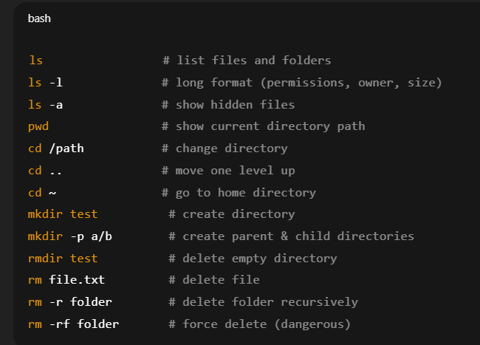

📄 FILE VIEWING COMMANDS
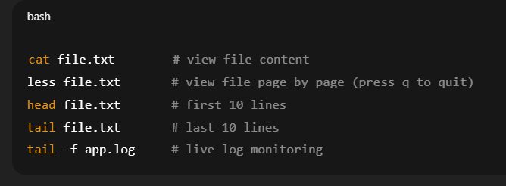

🔐 FILE PERMISSIONS & OWNERSHIP (VERY IMPORTANT)
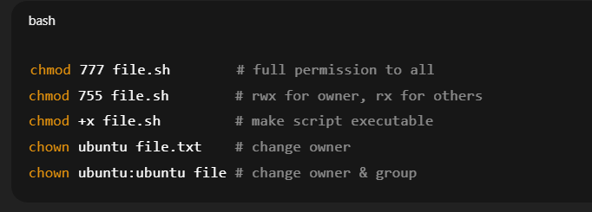

🧑 USER & SYSTEM INFO
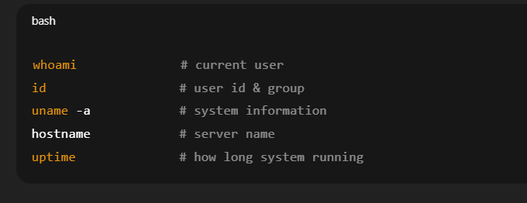

💾 DISK & MEMORY (INTERVIEW FAVORITE)
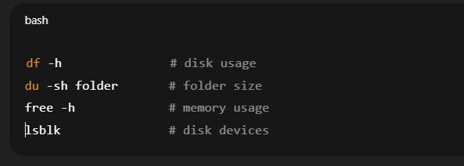

⚙️ PROCESS & PORT COMMANDS (EC2 CRITICAL)
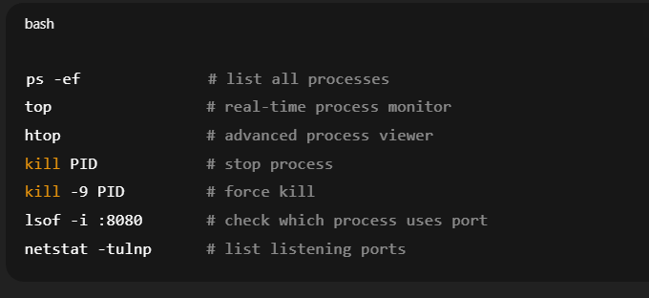

🌐 NETWORK COMMANDS
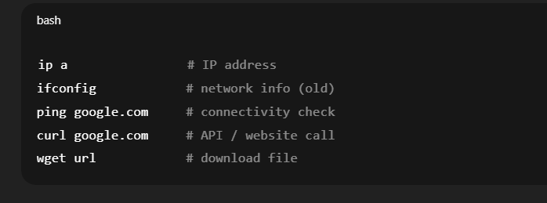

🔍 SEARCH & TEXT PROCESSING
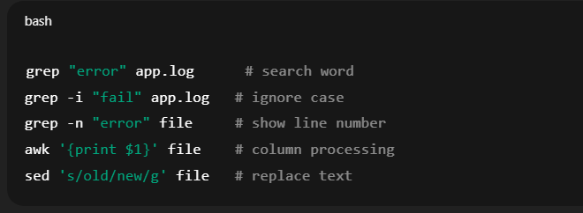

🔑 SSH & EC2 COMMANDS (VERY IMPORTANT)
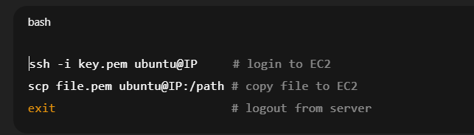

🧠 PACKAGE MANAGEMENT (UBUNTU EC2)
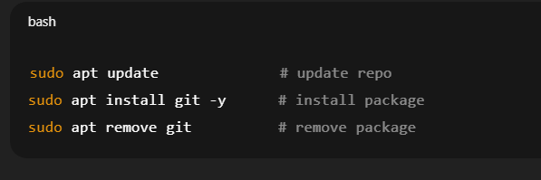

🕒 SERVICE & BACKGROUND JOBS
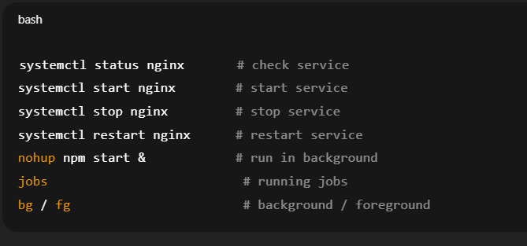

📝 LOG & CRON (INTERVIEW BONUS)

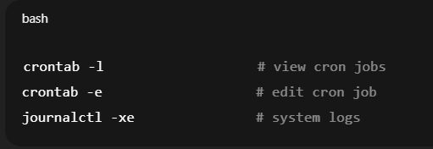

1.What is Shell & Bash?

Shell
-Shell is a command interpreter
-It takes command from user and gives it to Linux kernel
-Example:
-ls

Bash

-Bash = Bourne Again Shell
-Most commonly used shell in Linux
-Bash scripting = writing commands in a file and running them together

👉 Why Bash?
• Automation
• Deployment
• Monitoring
• DevOps tasks

2.Bash Script File
Bash script file ends with .sh
Contains Linux commands + logic
Example:
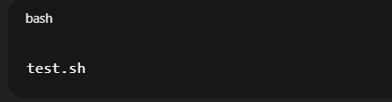
3️⃣ Shebang (Very Important)
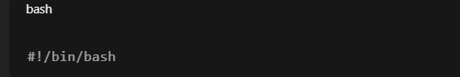

Meaning:
-Tells Linux which shell to use to run this script
-Must be first line

4️⃣ How to Create & Run Script

Create file:
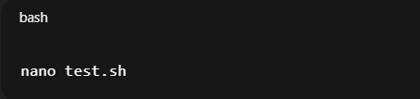

Make executable:
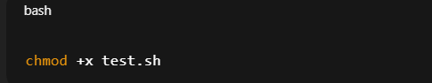

Run script:
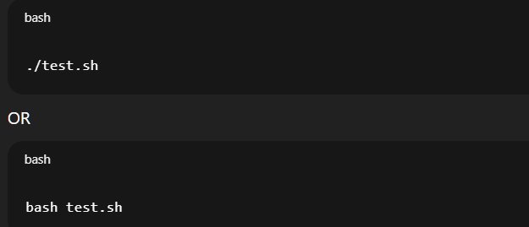
5️⃣ Comments
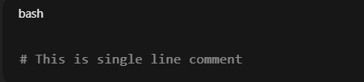
Multi-line comment:
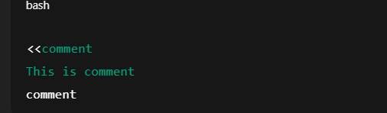

6️⃣ Variables (Store Data)

Create variable:
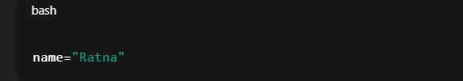

Use variable:
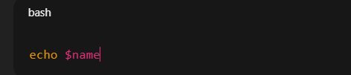

7️⃣ User Input
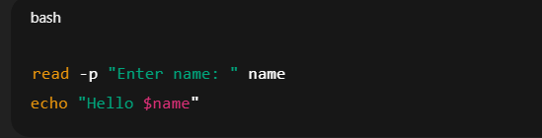

8️⃣ Command Line Arguments
Run:
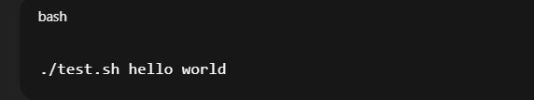

Inside script:
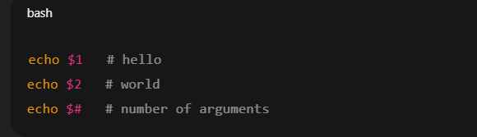

9️⃣ If Condition (Decision Making)
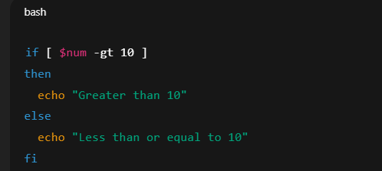

🔟 Loops (Repeat Work)

For loop
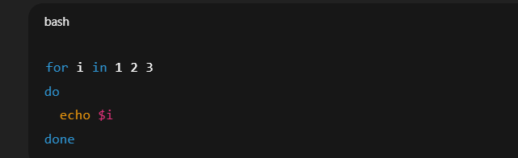

While loop

11. Functions (Reuse Code)
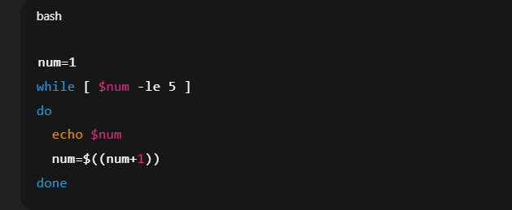

Exit Code & Error Handling
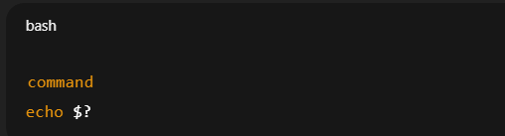

• 0 → success
• 1 → failure
Example:
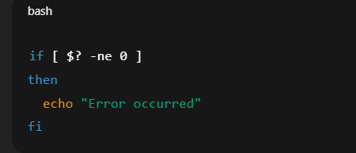

13.File Checking
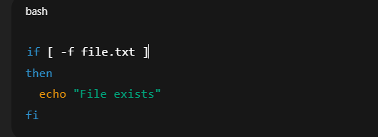

14.Input / Output Redirection
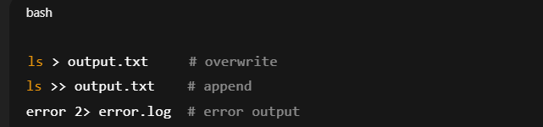

15.Pipes (Connect Commands)
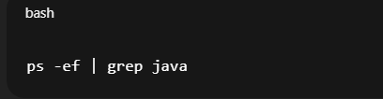

16.Background Process

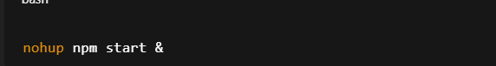
App runs even after logout.

17.Cron Job (Automation)
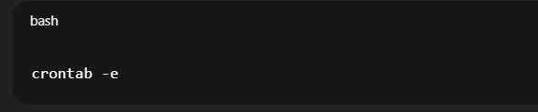

Example:


18.Debugging Script
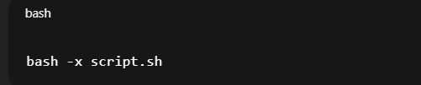
Shows step-by-step execution.

19.Bash for DevOps (Real Use)
- Deploy app
- Start / stop services
- Check disk space
- Backup files
- Monitor server
- Bash scripting is used to automate Linux tasks like deployment, monitoring, and server management.

Deployment Script

#!/bin/bash
set -e

trap 'echo "❌ Deployment failed at line $LINENO"; exit 1' ERR

APP_NAME="Book-finder-App"
REPO_URL="https://github.com/Ratnmala1007/Book-finder-App.git"

echo "************ DEPLOYMENT STARTED ************"

code_clone() {
echo "📥 Cloning or updating app..."

if [ -d "$APP_NAME" ]; then
echo "Repo exists, pulling latest code"
cd "$APP_NAME"
git pull
else
git clone "$REPO_URL"
cd "$APP_NAME"
fi
}

install_requirement() {
echo "📦 Installing dependencies..."
npm install
}

required_run() {
echo "🚀 Starting application..."
nohup npm start > app.log 2>&1 &
}

code_clone
install_requirement
required_run

echo "************ DEPLOYMENT COMPLETED ************"

Step | Action
Shebang + set -e | Run in bash, stop on errors
trap | Handle errors gracefully
code_clone | Clone repo if not present, else pull latest
install_requirement | Install all npm dependencies
required_run | Start app in background and log output
echo | Shows start/end messages

